CAS PY 106

Lecture Note 14

1. Electric Charge in a Magnetic Field
2. What is the force on a positive charge with a velocity moving parallel to the field, in either direction?
3. Zero
4. 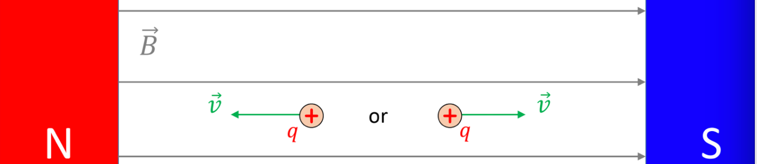
5. The magnitude of the magnetic force on a charge moving in a B-field is:

F = qvB\*sin(theta)

1. B-field measured in units of Tesla, or T where 1 T = 1 N \* s / C / m
2. Therefore, the magnitude of the force is maximal for theta = 90 degrees
3. The Force, in the situation above, is pointing into the screen
4. 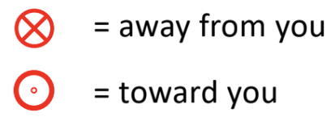
5. Charge moving in a uniform magnetic field
6. 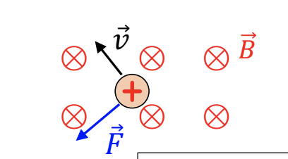
7. 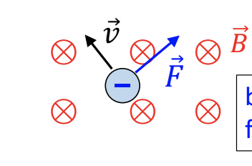
8. What happens if we have both, E-field and B-field?
9. 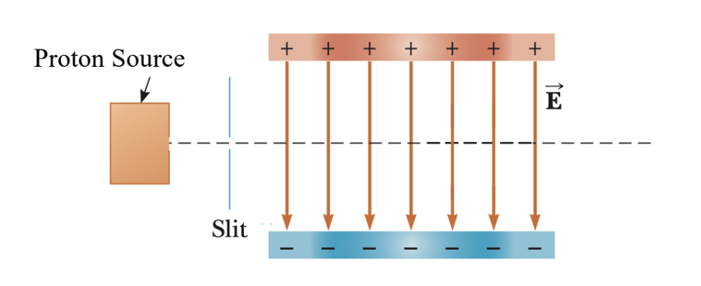
10. If you shoot protons through an E-field (through a parallel plate capacitor) the E-field will deflect the protons (F = qE)
11. At the same time, you could a magnet near the parallel plate capacitor and use the B-field to deflect the protons in the opposite direction (F = qvB) while v and B are perpendicular to each other
12. If the electric and magnetic forces are equal, the proton will travel straight
13. 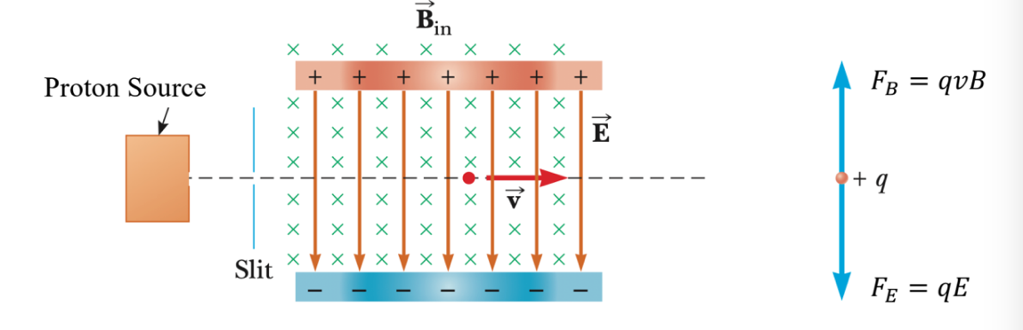
14. F = F

qE = qvB

v = E/B

1. If you change the strengths of E and B, you can choose to allow protons with a particular v to pass through your device
2. Is this charge too fast or too slow?
3. 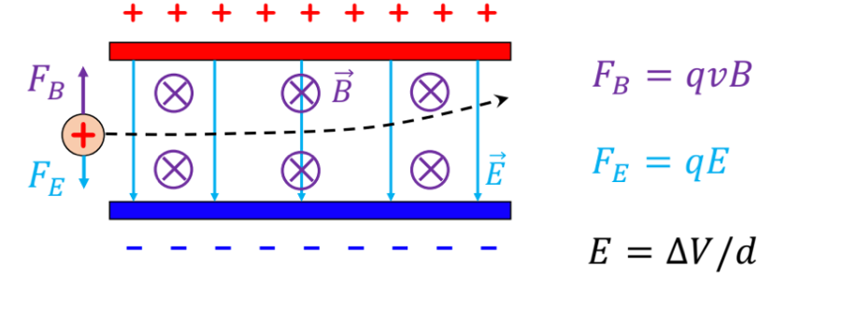
4. Assuming we want the charge to move through the velocity selector in a straight path, is the charge moving at the right speed?

Too fast

1. Since Fb is greater in magnitude than Fe, the charge is moving too fast
2. Direction of the Magnetic Force on a Charge
3. 2D image of a charge moving in a magnetic field
4. 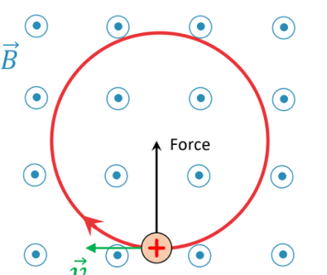
5. 3D image of a charge moving in a magnetic field
6. 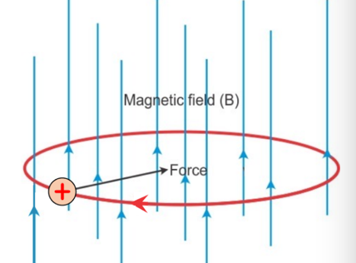
7. The force is perpendicular to velocity of the charge, which means we have uniform circular motion
8. Charge moving in a uniform magnetic field
9. F = ma = mv^2/r
10. F = qvB

mv^2/r = qvB

R = mv/qB

1. Period of circular orbit
2. If particle moves in a circle, how many seconds does it take for one round?

T = 2piR/v = 2pi\*m/qB